**Homework**  
**1- Visual Perception (1 Point)**  
When you enter a dark theater on a bright day, it takes an appreciable interval of time before you can seewell enough to find an empty seat. Which visual process is at play in this situation?

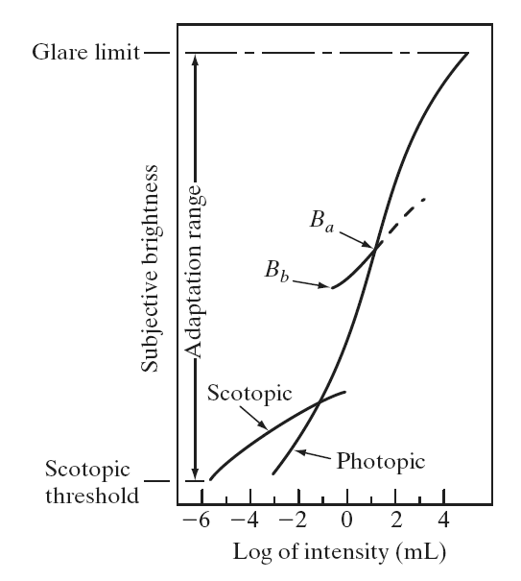Answer:

Scotopic vision it is not color sensitive. Scotopic vision is more sensitive to light (rods)

In human eye there when a person go to dark place from light place, it takes time to enlarge size of pupil (dilation).after the size of pupil changed more vision system adopt new condition. I think in this situation this slow increase of light is related to dark adaptation.

**2- Histogram (1 Point)**  
Suppose we have an image *f x y* ( , ) and its histogram is *hf* .  
(a) If *f x y c* ( , )× , and we ensure the maximum pixel value will not exceed 255, how would *hf*  
become?

Answer:

The idea of histogram is to show frequent number for each level. for example in this question if the value of histogram in between 50-150 when we multiply it by 0.5 the levels compressed and we will have darker image, but if (c) is more than one for example 1.5 we have lighter or faded image and the histogram have more spaces because some points are image are really light we lose information. The overall shape of histogram has been changed. and also level of each histogram in comparison to the original one.

The answer is examined by Matlab.

close all

clear all

I = imread('pout.tif');

J0=I(:)*10;

subplot(2,2,1)

imhist(I)

subplot(2,2,2)

imhist(J0)

subplot(2,2,3)

imshow(I)

subplot(2,2,4)

J=reshape(J0,[291,240]);

imshow(J)

(b) If *f x y c* ( , ) + , and we ensure the maximum pixel value will not exceed 255, how would *hf*  
become?

Answer:

in this situation because all the values just added by a constant the difference between two histogram in not noticeable. And the overall shape and of histogram has not been changed, but the value shifted to the right side of histogram.

(c) If we rotate the image *f x y* ( , ) by 90*o* clockwise, how would *hf* become?

Answer:

If we rotate the image by 90 degree clockwise the shape and value of histogram does not change and is same as original one.

close all

clear all

I = imread('pout.tif');

I2=imrotate(I,270);

I3=I2(:);

subplot(2,2,1)

imhist(I)

subplot(2,2,2)

imhist(I3)

subplot(2,2,3)

imshow(I)

subplot(2,2,4)

J=reshape(I3,[240,291]);

imshow(J)

­